Revisions to 2 CFR 200 (Uniform Guidance)

Background
- The Office of Management and Budget (OMB) amended Title 2 and 2 CFR 200 on October 1, 2024.
  - Approximately 560 changes to Title 2 – many are technical corrections
- Not all agencies have implemented the changes
  - NIH webinar last week “Still putting together our plans”
    - Follow current NIH GPS and award terms and conditions until new NIH GPS is released
  - NSF has adopted the changes through the Grant General Conditions (GC-1)
    - Effective for all new awards made on or after 10/1/24
    - Effective to all existing awards when the award is amended
  - HHS awards (including SAMSHA, HRSA, Indian Health Service, CDC, FDA)
    - 45 CFR 75 has not been updated yet
- General Guidance
  - For new awards made on or after 10/1/24 – follow the award terms and conditions and applicable regulations and/or agency guidance
  - For existing awards – continue to follow award terms and conditions and previous requirements until the award is amended. This applies to subawards as well.
  - For Other Transactional Agreements (OTAs), follow the award terms and conditions.
  - Subawards must be amended to incorporate the revisions when our prime award is amended by the federal government
- The date of the award is the day the agreement was signed by the government, not the start date of the Period of Performance.

Resources
- Council of Federal Financial Assistance – 2024 Revisions and Resources
- 2024 Crosswalk
- 2 CFR 200

Changes NOT Currently Applicable to the University of Colorado Denver | Anschutz Medical Campus
- The amendments revised some thresholds
- These changes are NOT APPLICABLE to our University until our next negotiated indirect cost rate agreement (NICRA) potentially in 2026 (or later)
Provision | UCD|AMC | 2 CFR 200
Equipment Threshold | $5,000 | $10,000
Subaward MTDC Exclusion | $25,000 | $50,000

- Always follow the more restrictive policy, which is almost always University policy
- These changes in threshold may be applicable to subrecipients, depending on the subrecipient’s NICRA and internal policies.
  - The change in threshold will only apply to subrecipients upon execution of their NICRA AND an amendment or new subaward from our institution.
  - PIs and Departments are responsible for subrecipient monitoring and ensuring subrecipients follow their internal policies.

Title 2 Changes
- 2 CFR 25 – Unique Entity Identifier and System for Award Management
  - Clarification – subrecipients need a UEI but not fully SAM registration for federal grants
  - SAM registration is required for contracts
- 2 CFR 175 – Award Terms for Trafficking in Persons
  - New requirement – applicable when over $500,000 spent outside the United States on a federal grant
    - Must develop a plan to monitor, detect, and terminate any subrecipient, contractor, or employee that engages or support human trafficking, forced labor, or procuring commercial sex acts
    - Requirements for compliance plans found at 2 CFR 175.105(b)
    - University must certify compliance plans have been developed and provide the compliance plans upon request to the federal agency and/or auditor
  - Application – verify if any federal award expends more than $500,000 in foreign locations under a federal grant ($550,000 for a federal contract) and develop a plan

2 CFR 200 – General Terminology Changes
- “Cost Share or Matching” is now “cost share” to better indicate that match is one category of cost share
- “Non-federal entity” is now “recipient” or “subrecipient” to better highlight a pass-through entity’s responsibilities for subrecipient monitoring and to differentiate between the responsibilities of a recipient and subrecipient
- “Indirect (F&A) costs” is now “indirect costs”
- One-Time Extension and No Cost Extension
  - One-Time Extension now refers to the authority to extend the period of performance up to 12 months without prior approval
  - No Cost Extension now refers to the prior approval request to extend the period of performance beyond the one-time extension or when authority is not granted for a one-time extension
- “Intangible property” expanded definition to include: data, websites, IP licenses, trade secrets, patents, stocks, software, and software subscriptions/licenses
- “Participant” is now anyone not committing effort or delivery of a program activity, previously a participant had to be a non-employee

2 CFR 200 – Subpart B – General Provisions and Subpart C – Pre-Award Requirements
§200.113 Mandatory Disclosures
- Must only report criminal violations when “credible evidence” exists
- Must be reported to both the sponsor (agency or pass-through entity) and the Agency Office of Inspector General
  - Reminder: If you must report something under this section, you need to reach out to TK Keith first.
  - You can report fraud, waste, and abuse to CU EthicsLine
§ 200.201 Use of Grants, Cooperative Agreements, Fixed Amount Awards, and Contracts
- Significant changes made to fixed amount awards
  - Requires the use of the cost principals (previously was only used as guidance) and requires the use of “accurate costs, historical or unit pricing data” for all costs
  - Added prior approval requirements
  - Clarifies that a recipient or subrecipient may retain a residual balance on a completed fixed amount award
  - Increases the maximum amount of a fixed amount award to $500,000
  - Allows auditors to review pricing and costing documents
- Impact of changes
  - Significantly increases the audit risk to pass-through entities
  - Fundamentally changes the concept of a fixed amount award by increasing burden
- Change in University Process
  - The University will only make cost reimbursable subawards to protect the University from audit risks – existing fixed amount subawards may continue through the period of performance
  - The University can continue to receive fixed amount awards, since the audit risk would be on the sponsor and pass-through entity
  - If proposing a fixed amount award, be sure to carefully review the new requirements
§ 200.204 Notices of Funding Opportunities
  - Modifies the standard governmentwide template for NOFOs
§ 200.206 Federal Agency Review of Risk Posed by Applicants
  - Expands the risk assessment to include cybersecurity risks
§ 200.216 Prohibition on Certain Telecommunication and Video Surveillance Services of Equipment
  - Clarifies that recipients and subrecipients may use prohibited items, but cannot use federal funds for them
  - Applies program income and cost sharing requirements to this section
  - Does not require additional certification from recipients or subrecipients beyond the initial required certification
  - Significance: Make sure foreign subrecipients are not using federal funds to purchase prohibited items
§ 200.217 Whistleblower Protections
  - New section to incorporate existing federal whistleblower protections for recipient and subrecipient employees

2 CFR 200 – Subpart D – Post Award Administrative Requirements
- § 200.305 Federal Payment
  - Expands exceptions for international recipients and subrecipients not to use an interest-bearing account to hold federal funds
- § 200.306 Cost Sharing
  - Limits an agency’s ability to use voluntary committed cost sharing as a consideration during the merit review, unless allowed by the agency’s regulations and incorporated in the NOFO
- § 200.307 Program Income
  - Provides clarification on program income
  - Allows program income to be used to cover allowable closeout costs (See § 200.472)
- § 200.308 Revisions of Budget and Program Plans
  - Modifies standard governmentwide prior approval requirements
    - “Change in key personnel specified in the recipient’s or subrecipient’s application in the Federal Award.”
    - Prior approval for a change in subrecipient only requires prior approval if a term is included in the award terms and conditions, which should only occur when the subrecipient was a determining factor in the merit review process
    - No Cost Extension (does not apply to one-time extension authority)
- § 200.313 Equipment
  - The recipient or subrecipient must notify the federal agency or pass-through entity of loss, damage, or theft of equipment that will have an impact on the program
    - This applies to non-exempt property only. For exempt property, contact the Finance Office.
- § 200.317 Procurements by States and Indian Tribes
  - Allows Native American entities to use their own procurement rules
  - Subrecipient Monitoring: Verify Native American have written policies
- § 200.318 General Procurement Standards
  - Requires contractors (vendors) to properly classify consultants
- Procurement Standards under § § 200.319-326
  - There are some changes/modifications/clarifications/recommendations under the procurement standards. Any changes to the University’s procurement system, policies, and procedures must be adopted by the Procurement Service Center (PSC)
  - Continue to follow the PSC Procurement Rules
- § 200.322 Domestic Preferences for Procurements
  - Clarifies the Buy America provisions are only required for infrastructure grants
- § 200.332 Requirements for Pass-through Entities
  - Requires PTEs notify federal agencies when specific conditions are applied to a subaward.
- § 200.340 Termination
  - Removes the ability of federal agencies and pass-through entities from terminating an award if it “no longer effectuates the program goals or agency priorities”
    - Comment: This prevents an agency from terminating an award for political or ideological reasons
- § 200.342 Opportunities to Object, Hearings, and Appeals
  - Includes language that requires pass-through entities to maintain written procedures to allow a subrecipient to object to a subaward termination.
    - Comment: The University will need to adopt procedures to comply with this section

2 CFR 200 – Subpart E – Cost Principles
- § 200.403 Factors Affecting Allowability of Costs
  - Allows for administrative closeout costs to be incurred and charged to the final budget period (See § 200.472)
- § 200.407 Prior Approval
  - Removes prior approval requirements for the following select items of cost:
    - Real property;
    - Equipment;
    - Salaries of administrative and clerical staff directly charged to the award;
    - Entertainment costs;
    - Exchange rates;
    - Membership, subscriptions, and professional activity costs;
    - Participant support costs;
    - Selling and marketing costs; and
    - Taxes
  - Federal agencies may still require prior approval for these selected items of cost if incorporated into the award terms and conditions. The adherence to the cost principles (allowable, necessary and reasonable, and allocable) still applies.
  - This change does not mean we can automatically directly charge the salaries of research administrators to an award. We must still conform with the requirements under 2 CFR 200.413(c).
  - Adding participant support cost does not require prior approval, but prior approval to rebudget participant support costs remains
- § 200.414 Indirect Costs
  - Allows recipients to file a complaint with OMB if a federal agency does not recognize a negotiated indirect cost rate
  - Raises the de minimis rate to 15% MTDC (currently 10% MTDC)
    - Subrecipient Monitoring: If a subrecipient does not have a current negotiated rate, the subrecipient may elect to charge the de minims or negotiate a rate with the pass-through entity. A pass-through entity may not force the de minimis rate onto a subrecipient. If a subrecipient has a negotiated rate, we must accept that on federal awards unless prohibited or limited by federal law. The change in the de minimis rate only impacts new subawards issued under a prime award made after the federal agency has adopted the increased threshold.
- § 200.415 Required Financial Certifications
  - Subrecipients must certify to the pass-through entity whenever applying for funds, requesting payment, and submitting reports the following statement: “I certify to the best of my knowledge and belief that the information provided herein is true, complete, and accurate. I am aware that the provision of false, fictitious, or fraudulent information, or the omission of any material fact, may subject me to criminal, civil, or administrative consequences including, but not limited to violations of U.S. Code Title 18, Sections 2, 1001, 1343 and Title 31, Sections 3729–3730 and 3801–3812.” This applies to all tiers of subrecipients.
- § 200.432 Conferences
  - Providing locally available dependent-care resources for conference participants is allowable
    - Comment: Ensure these costs are included in the proposal
- § 200.455 Organizational Costs
  - Funds cannot be used to encourage or deter union organization or collective bargaining
  - Clarifies that costs related to data and evaluation are allowable
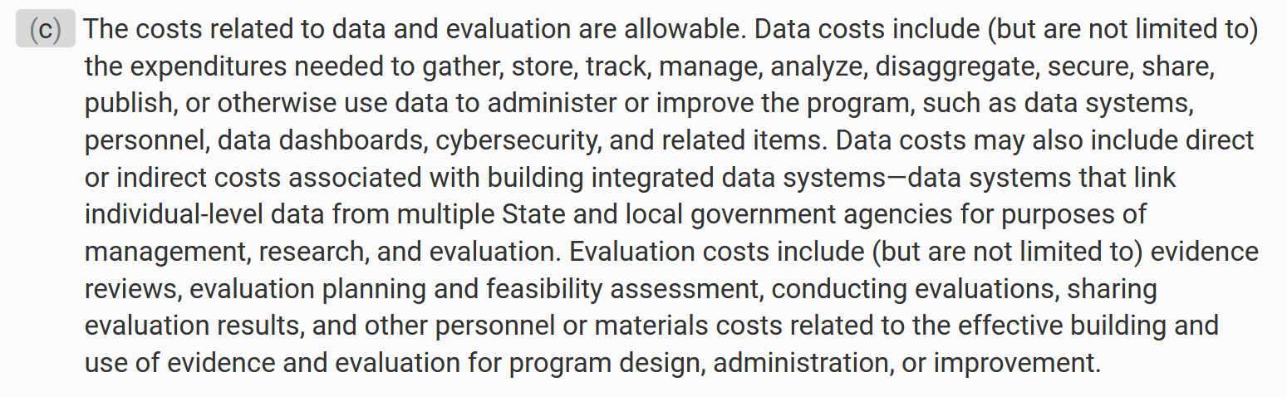

- § 200.456 Participant Support Costs
  - Prior approval requirements for these costs are removed; however, rebudgeting participant support costs still requires prior approval as provided by 2 CFR 200.308
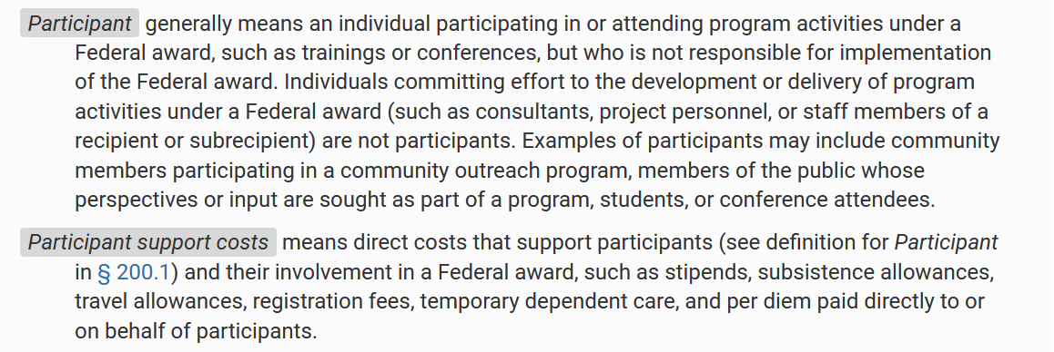

  - Comment: 2 CFR 200 requires institutions to adopt policies for classification of these costs. The University will need to implement a policy.
  - Subrecipient Monitoring: Need to verify the subrecipient has written policies for participant support costs before allowing charges
- § 200.461 Publication and Printing Costs
  - Costs can include “article processing charges or similar open access fees” for professional journal publications and other peer-reviewed publications
- § 200.472 Termination and Standard Closeout Costs
  - Allows for administrative costs associated with closeout to be charged to the final budget period
    - Comment: The University will need to develop policies/procedures for these costs
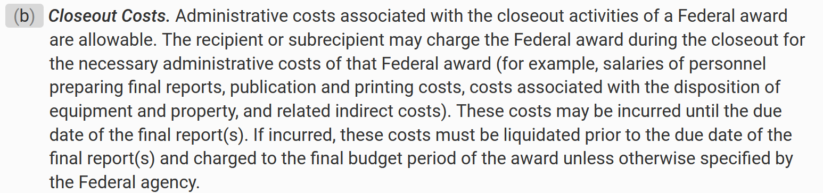

Subpart F – Audit Requirements
- § 200.501 Audit Requirements
  - Raises the single audit threshold to $1 million (from $750,000)
    - Comment: The University may need to update internal policies/procedures related to subrecipients to reflect this threshold change

